User Age Group   
These Groups were made using the histogram(To define Bins) and some practical assumptions.

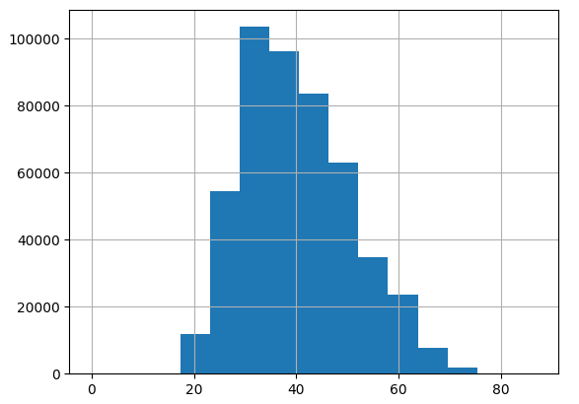

[{"Cluster" : 1, "ClusterInfo":{"MinAge":17,"MaxAge":22 }},

{"Cluster" : 2, "ClusterInfo":{"MinAge":22,"MaxAge":28 }},

{"Cluster" : 3, "ClusterInfo":{"MinAge":28,"MaxAge":33 }},

{"Cluster" : 4, "ClusterInfo":{"MinAge":33,"MaxAge":39 }},

{"Cluster" : 5, "ClusterInfo":{"MinAge":39,"MaxAge":44 }},

{"Cluster" : 6, "ClusterInfo":{"MinAge":44,"MaxAge":50 }},

{"Cluster" : 7, "ClusterInfo":{"MinAge":50,"MaxAge":55 }},

{"Cluster" : 8, "ClusterInfo":{"MinAge":55,"MaxAge":60 }},

{"Cluster" : 9, "ClusterInfo":{"MinAge":61,"MaxAge":66 }},

{"Cluster" : 10,"ClusterInfo":{"MinAge":66,"MaxAge":72 }},

{"Cluster" : 11,"ClusterInfo":{"MinAge":72,"MaxAge":80 }}]

Hyper parameter Tunned

The best model has 8 latent factors and regularization = 0.001

RMSE Error is 0.8796292214136551

User Group ON Location Data

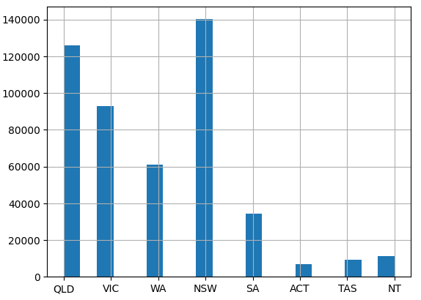

{'QLD': 1, 'VIC': 2, 'WA': 3, 'NSW': 4, 'SA': 5, 'ACT': 6, 'TAS': 7, 'NT': 8}

The best model has 10 latent factors and regularization = 0.001

RMSE Error is 0.8806331149965555

User Group ON Location Data & AGE

These Groups were made using the histogram(To define Bins) and some practical assumptions about each state.

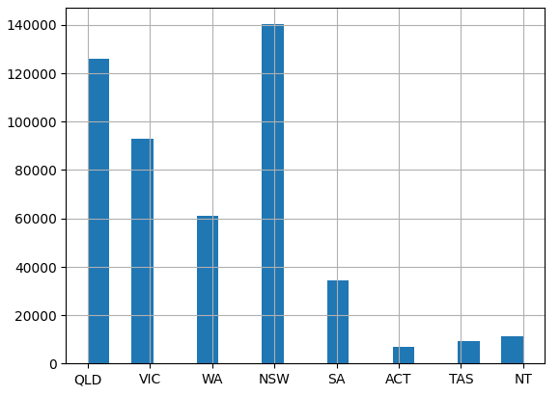

{'Cluster': 1, 'ClusterInfo': {'MinAge': 16, 'MaxAge': 22, 'State': 'QLD'}},

{'Cluster': 2, 'ClusterInfo': {'MinAge': 16, 'MaxAge': 22, 'State': 'VIC'}},

{'Cluster': 3, 'ClusterInfo': {'MinAge': 16, 'MaxAge': 22, 'State': 'WA'}},

{'Cluster': 4, 'ClusterInfo': {'MinAge': 16, 'MaxAge': 22, 'State': 'NSW'}},

{'Cluster': 5, 'ClusterInfo': {'MinAge': 16, 'MaxAge': 22, 'State': 'SA'}},

{'Cluster': 6, 'ClusterInfo': {'MinAge': 16, 'MaxAge': 22, 'State': 'ACT'}},

{'Cluster': 7, 'ClusterInfo': {'MinAge': 16, 'MaxAge': 22, 'State': 'TAS'}},

{'Cluster': 8, 'ClusterInfo': {'MinAge': 16, 'MaxAge': 22, 'State': 'NT'}},

{'Cluster': 9, 'ClusterInfo': {'MinAge': 22, 'MaxAge': 28, 'State': 'QLD'}},

{'Cluster': 10, 'ClusterInfo': {'MinAge': 22, 'MaxAge': 28, 'State': 'VIC'}},

{'Cluster': 11, 'ClusterInfo': {'MinAge': 22, 'MaxAge': 28, 'State': 'WA'}}, ...

{'Cluster': 37, 'ClusterInfo': {'MinAge': 39, 'MaxAge': 44, 'State': 'SA'}},

{'Cluster': 38, 'ClusterInfo': {'MinAge': 39, 'MaxAge': 44, 'State': 'ACT'}},

{'Cluster': 39, 'ClusterInfo': {'MinAge': 39, 'MaxAge': 44, 'State': 'TAS'}},

{'Cluster': 40, 'ClusterInfo': {'MinAge': 39, 'MaxAge': 44, 'State': 'NT'}},

{'Cluster': 41, 'ClusterInfo': {'MinAge': 44, 'MaxAge': 50, 'State': 'QLD'}},

{'Cluster': 42, 'ClusterInfo': {'MinAge': 44, 'MaxAge': 50, 'State': 'VIC'}}, ...

{'Cluster': 79, 'ClusterInfo': {'MinAge': 66, 'MaxAge': 72, 'State': 'TAS'}},

{'Cluster': 80, 'ClusterInfo': {'MinAge': 66, 'MaxAge': 72, 'State': 'NT'}},

{'Cluster': 81, 'ClusterInfo': {'MinAge': 72, 'MaxAge': 80, 'State': 'QLD'}}, ...

{'Cluster': 86, 'ClusterInfo': {'MinAge': 72, 'MaxAge': 80, 'State': 'ACT'}},

{'Cluster': 87, 'ClusterInfo': {'MinAge': 72, 'MaxAge': 80, 'State': 'TAS'}},

{'Cluster': 88, 'ClusterInfo': {'MinAge': 72, 'MaxAge': 80, 'State': 'NT'}}]

The best model has 60 latent factors and regularization = 0.01

RMSE Error is 0.8610734089037843

User_Group_ON_Location_Data_&_AGE_&_ Income

Algorithm used :: Cluster making

E.g. :

[ {'ClusterID': 2, 'ClusterInfo': {'MinIncome': -291.44, 'MaxIncome': 9708.56, 'MinAge': 16, 'MaxAge': 22, 'State': 'QLD'}},

{'ClusterID': 3, 'ClusterInfo': {'MinIncome': -291.44, 'MaxIncome': 9708.56, 'MinAge': 16, 'MaxAge': 22, 'State': 'VIC'}},

{'ClusterID': 4, 'ClusterInfo': {'MinIncome': -291.44, 'MaxIncome': 9708.56, 'MinAge': 16, 'MaxAge': 22, 'State': 'WA'}},

{'ClusterID': 5, 'ClusterInfo': {'MinIncome': -291.44, 'MaxIncome': 9708.56, 'MinAge': 16, 'MaxAge': 22, 'State': 'NSW'}},

{'ClusterID': 6, 'ClusterInfo': {'MinIncome': -291.44, 'MaxIncome': 9708.56, 'MinAge': 16, 'MaxAge': 22, 'State': 'SA'}},

{'ClusterID': 7, 'ClusterInfo': {'MinIncome': -291.44, 'MaxIncome': 9708.56, 'MinAge': 16, 'MaxAge': 22, 'State': 'ACT'}},

{'ClusterID': 8, 'ClusterInfo': {'MinIncome': -291.44, 'MaxIncome': 9708.56, 'MinAge': 16, 'MaxAge': 22, 'State': 'TAS'}},

{'ClusterID': 9, 'ClusterInfo': {'MinIncome': -291.44, 'MaxIncome': 9708.56, 'MinAge': 16, 'MaxAge': 22, 'State': 'NT'}},

{'ClusterID': 10, 'ClusterInfo': {'MinIncome': -291.44, 'MaxIncome': 9708.56, 'MinAge': 22, 'MaxAge': 28, 'State': 'QLD'}},

{'ClusterID': 11, 'ClusterInfo': {'MinIncome': -291.44, 'MaxIncome': 9708.56, 'MinAge': 22, 'MaxAge': 28, 'State': 'VIC'}},

{'ClusterID': 12, 'ClusterInfo': {'MinIncome': -291.44, 'MaxIncome': 9708.56, 'MinAge': 22, 'MaxAge': 28, 'State': 'WA'}},

{'ClusterID': 13, 'ClusterInfo': {'MinIncome': -291.44, 'MaxIncome': 9708.56, 'MinAge': 22, 'MaxAge': 28, 'State': 'NSW'}},

{'ClusterID': 14, 'ClusterInfo': {'MinIncome': -291.44, 'MaxIncome': 9708.56, 'MinAge': 22, 'MaxAge': 28, 'State': 'SA'}},

{'ClusterID': 15, 'ClusterInfo': {'MinIncome': -291.44, 'MaxIncome': 9708.56, 'MinAge': 22, 'MaxAge': 28, 'State': 'ACT'}},

{'ClusterID': 16, 'ClusterInfo': {'MinIncome': -291.44, 'MaxIncome': 9708.56, 'MinAge': 22, 'MaxAge': 28, 'State': 'TAS'}},

{'ClusterID': 17, 'ClusterInfo': {'MinIncome': -291.44, 'MaxIncome': 9708.56, 'MinAge': 22, 'MaxAge': 28, 'State': 'NT'}},

{'ClusterID': 18, 'ClusterInfo': {'MinIncome': -291.44, 'MaxIncome': 9708.56, 'MinAge': 28, 'MaxAge': 33, 'State': 'QLD'}},

{'ClusterID': 19, 'ClusterInfo': {'MinIncome': -291.44, 'MaxIncome': 9708.56, 'MinAge': 28, 'MaxAge': 33, 'State': 'VIC'}},

{'ClusterID': 20, 'ClusterInfo': {'MinIncome': -291.44, 'MaxIncome': 9708.56, 'MinAge': 28, 'MaxAge': 33, 'State': 'WA'}}....]

60 latent factors and regularization = 0.01

RMSError = 0.8515969197892825

N_Cluster = 300

{ClusterId: 0,

ClusterInfo:{Age:(0.402298851 ) , State:(0.428571429),Income:(8.83E-06 0.005589869)}}

{ClusterId: 1,

ClusterInfo:{Age:(0.471264368) , State:(0.857142857) ,Income:(8.83E-06 0.003239278)}}

{ClusterId: 99,

ClusterInfo:{Age:(0.67816092) , State:(1),Income:(8.83E-06 0.003590103)}}

{ClusterId: 179,

ClusterInfo:{Age:(0.597701149) , State:(0.142857143) ,Income:(8.83E-06 0.003875318)}}

{ClusterId: 297,

ClusterInfo:{Age:(0.505747126), State:(0.285714286) ,Income:(8.83E-06 0.000323133)}}

Hyper Parameter of ALS = 200 latent factors and regularization = 0.01

Error = 84.58830934721 %

N_Cluster = 3000

{ClusterId: 0,

ClusterInfo:{Age:(0.2298 ) , State:(0.142857143),Income:(9.76E-05 0.000118979)}}

{ClusterId: 1,

ClusterInfo:{Age:(0.413793103) , State:(0.857142857) ,Income:(7.63E-05 0.000106837)}}

{ClusterId: 999,

ClusterInfo:{Age:(0.632183908) , State:(0.142857143),Income:(0.000187006 0.000234142)}}

{ClusterId: 1551,

ClusterInfo:{Age:(0.551724138) , State:(0.428571429) ,Income:(0.002777629 0.002902449)}}

{ClusterId: 2976,

ClusterInfo:{Age:(0.356321839), State:(0.142857143) ,Income:(0.001667974 0.001729366)}}

Hyper Parameter of ALS = 60 latent factors and regularization = 0.01

Error = 0.8068695789073171

Iterations = 15

Hyper Parameter of ALS = 200 latent factors and regularization = 0.01

Error is 0.8061559113153072